MAWLANA BHASHANI SCIENCE AND TECHNOLOGY UNIVERSITY
SANTOSH, TANGAIL-1902



DEPARTMENT OF INFORMATION AND COMMUNICATION TECHNOLOGY
Lab Report

Lab Report No : 02
Lab Report on : Arithmetic and Logical Operations on a Color Image using MATLAB
Course Title : Digital Image Processing Lab
Course Code : ICT-4104

Submitted By | Submitted To
Name: Kuldip Saha Mugdha  ID: IT-22018  4th Year, 1st Semester  Session: 2021-2022  Dept. of ICT, MBSTU | Dr. Mst. Nargis Akter  Professor  DEPARTMENT OF INFORMATION AND COMMUNICATION TECHNOLOGY  MAWLANA BHASHANI SCIENCE AND TECHNOLOGY UNIVERSITY

Date of Performance: 05/05/26 Date of Submission: 12/05/26
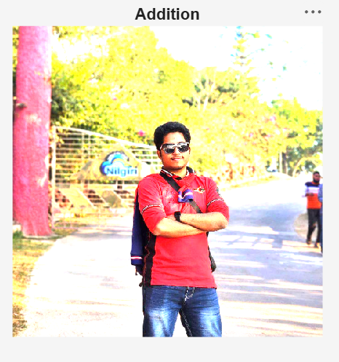
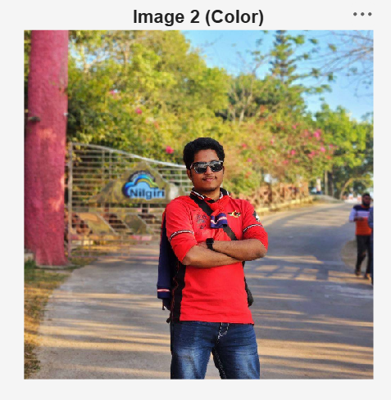
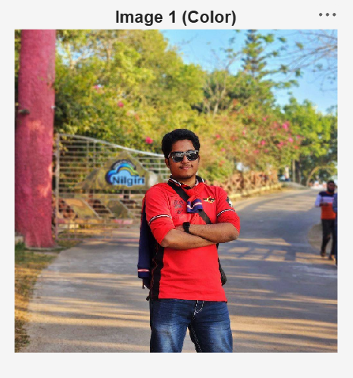

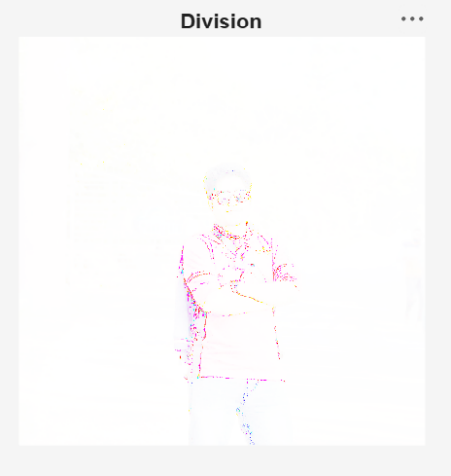
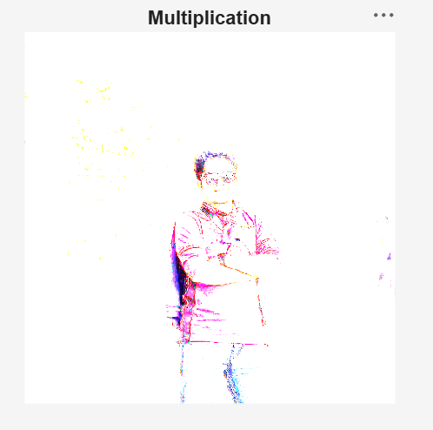
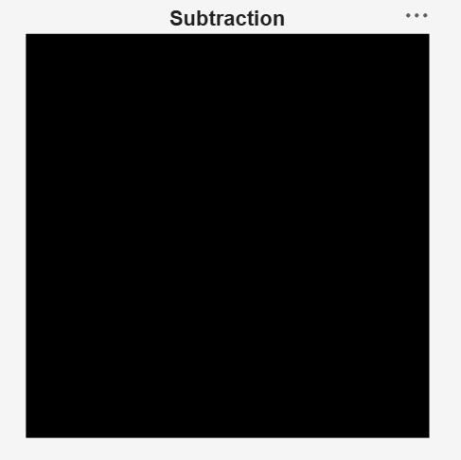

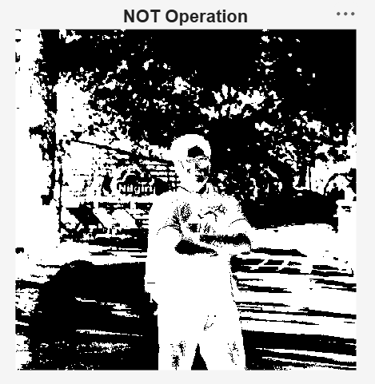
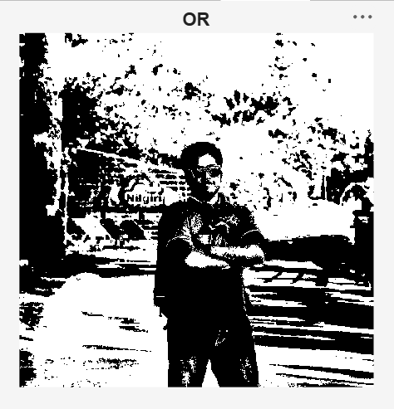
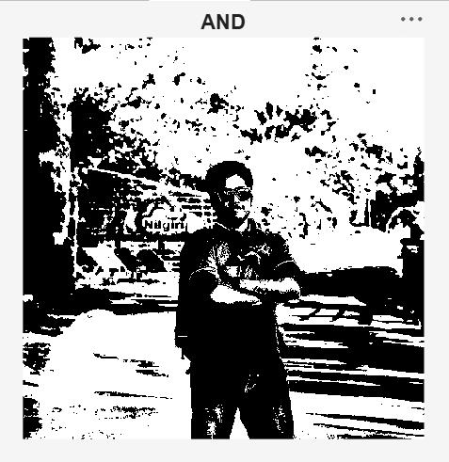

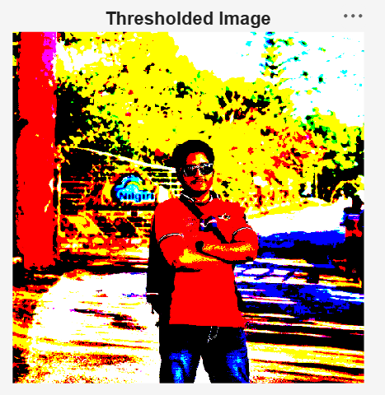
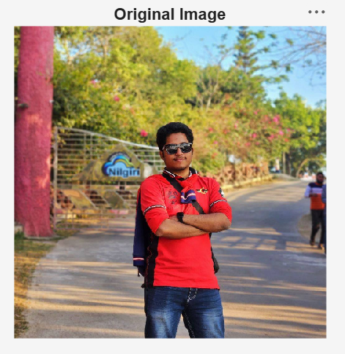

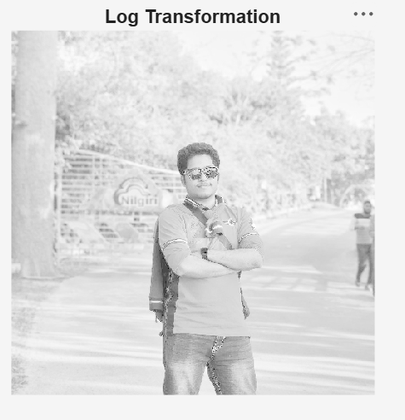
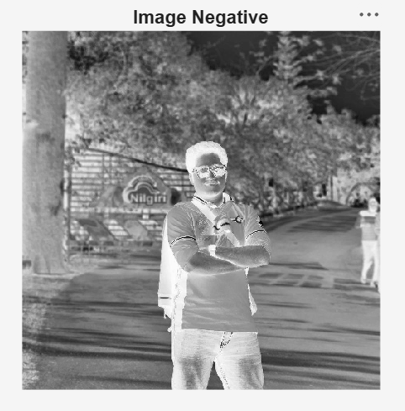
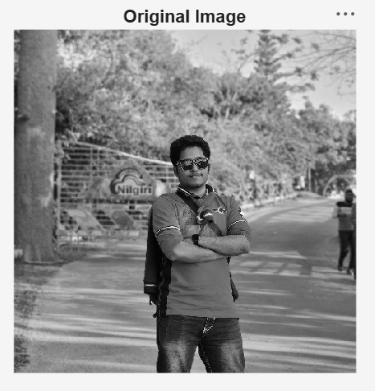

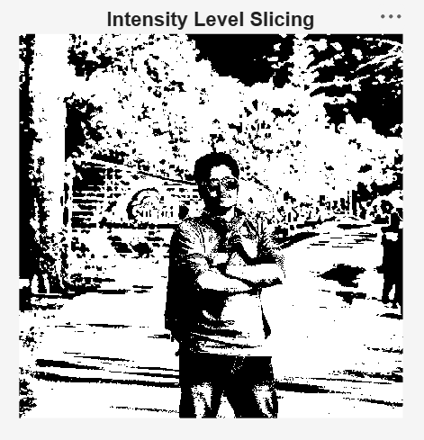
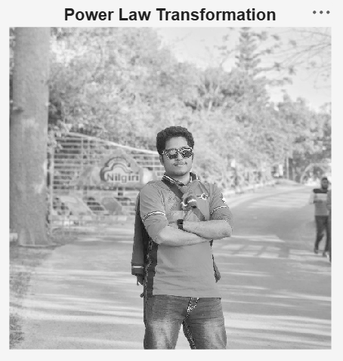

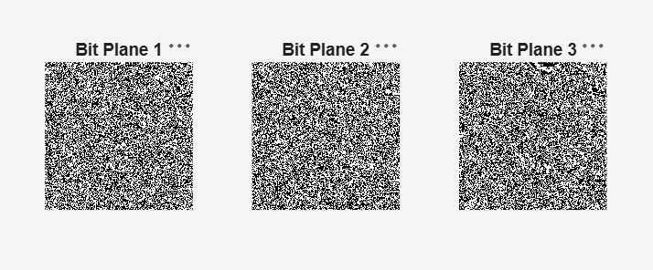

MAWLANA BHASHANI SCIENCE AND TECHNOLOGY UNIVERSITY
SANTOSH, TANGAIL-1902

DEPARTMENT OF INFORMATION AND COMMUNICATION TECHNOLOGY
Lab Report

Lab Report No : 03
Lab Report on : Implementation of Image Enhancement Techniques Using MATLAB
Course Title : Digital Image Processing Lab
Course Code : ICT-4104

Submitted By | Submitted To
Name: Kuldip Saha Mugdha  ID: IT-22018  4th Year, 1st Semester  Session: 2021-2022  Dept. of ICT, MBSTU | Dr. Mst. Nargis Akter  Professor  DEPARTMENT OF INFORMATION AND COMMUNICATION TECHNOLOGY  MAWLANA BHASHANI SCIENCE AND TECHNOLOGY UNIVERSITY

Date of Performance: 12/05/26 Date of Submission: 19/05/26

